1(a). Explain the importance of cloud application designs?

Cloud computing is so important because it offers flexibility, data recovery, little to no maintenance, easy access and a higher level of security.

**Flexibility**

Does your business experience fluctuating bandwidth requirements? Some months are busier, while others are not as intense. With cloud computing, managing resources is easier than ever. Simply pay for the resources you are using each month, and nothing more. Cloud storage and cloud VPS providers offer flexible packages, where you can easily add or decrease the amount of storage and bandwidth you are paying to use.

**Data Recovery**

Recovering data from damaged physical servers and hard drives can be fairly problematic. If the physical device is badly damaged, recovery may not be possible. These issues can result in businesses losing vital data, especially when it is not adequately backed up. With cloud computing, these issues are not as relevant.

When data is stored on the cloud, it is usually stored by the provider in multiple locations. That means your data is not just saved in one physical location. Even if they have a problem with one of their servers or massive storage locations, your data is safe as a copy is present at another location.

Small businesses rarely have the infrastructure or finances to set up complex and secure physical backup systems. But with cloud computing and storage, they can get an excellent service at an affordable price.

**No Maintenance**

When running a traditional server setup, companies must worry about the maintenance of the entire system. Not only are regular checks mandatory, but parts constantly need replacing as they stop working or become outdated.

A cloud computing solution eliminates the need for any maintenance. There is no cost or effort required by companies that use cloud solutions, as everything is handled by the provider. That removes a massive headache off your shoulders, and ensures the monthly expenditure is limited to what is paid for the cloud services being used.

**Easy Access**

Access to documents, backend files, software and the company website is much easier with cloud computing. It is effortless for employees to work remotely, while the entire company is connected through its cloud interface. All your employees will require is a device to access the network, and the correct security protocols.

**Increased Security**

With cloud computing, everything you are accessing and saving is on the cloud. Even if a laptop is lost or damaged, the company interface is accessible through another device. And since all your documents save on the cloud, there is no concern about losing important documents because they were saved on a now lost or damaged laptop hard drive.

Since information is no longer contained on your physical hard drives or servers, it also becomes a lot harder for anyone to steal. With a comprehensive encryption and login security system, company data is much safer with cloud computing.

The cloud is here, and it is already transforming how many companies operate. Businesses may be reluctant to change up existing operations, but the benefits of the cloud means the transition is worth it.

(b). Summarize the need of Reliability & Availability, Security in cloud application designs?

## What is reliability in cloud computing?

When you access an app or service in the cloud, you can reasonably expect that:

* The app or service is up and running.
* You can access what you need from any device at any time from any location.
* There will be no interruptions or downtime.
* Your connection is secure.
* You will be able to perform the tasks you need to get your job done.

Factors like these measure the reliability of your cloud offerings. In a perfect world, your system would be 100% reliable. But that is probably not an attainable goal. In the real world, things will go wrong. You will see faults from things such as server downtime, software failure, security breaches, user errors, and other unexpected incidents.

Proper planning and [cloud visualization](https://www.lucidchart.com/blog/why-visualize-your-cloud-infrastructure) can help you address faults quickly so that they don’t become huge problems that keep people from accessing your cloud offerings. The cloud makes it easy to build fault-tolerance into your infrastructure. You can easily add extra resources and allocate them for redundancy.

Employing measures that make your cloud system more reliable ensures that:

* Redundant resources kick in automatically when the system experiences a fault.
* There is no downtime and products and services remain available.
* Employees keep doing their jobs without knowing that something went wrong.

Reliability in cloud computing is important for businesses of any size. Buggy software can cause lost productivity, lost revenue, and lost trust in your brand. Before you deploy your applications to the cloud, make sure they are thoroughly tested against a variety of real-world scenarios. This helps to ensure that they are reliable and will meet customer expectations.

## What is availability in cloud computing?

High availability is the ultimate goal of moving to the cloud. The idea is to make your products, services, and tools available to your customers and employees at any time from anywhere using any device with an internet connection.

Cloud availability is related to cloud reliability.

For example, let’s say you have an online store that is available 24/7. But sometimes clicking the “checkout” button kicks customers out of the system before they have completed the purchase. So, your store may be available all the time, but if the underlying software is not reliable, your cloud offerings are basically useless.

**Security In Cloud Computing :**

Cloud computing which is one of the most demanding technology of the current time, starting from small to large organizations have started using cloud computing services. Where there are different types of cloud deployment models are available and cloud services are provided as per requirement like that internally and externally security is maintained to keep the cloud system safe. Cloud computing security or cloud security is an important concern which refers to the act of protecting cloud environments, data, information and applications against unauthorized access, DDOS attacks, malwares, hackers and other similar attacks. Community Cloud :  These allow to a limited set of organizations or employees to access a shared cloud computing service environment.

**Planning of security in Cloud Computing :**

As security is a major concern in cloud implementation, so an organization have to plan for security based on some factors like below represents the three main factors on which planning of cloud security depends.

* Resources that can be moved to the cloud and test its sensitivity risk are picked.
* The type of cloud is to be considered.
* The risk in the deployment of the cloud depends on the types of cloud and service models.

**Types of Cloud Computing Security Controls :**

There are 4  types of cloud computing security controls i.e.

1. **Deterrent Controls** : Deterrent controls are designed to block nefarious attacks on a cloud system. These come in handy when there are insider attackers.
2. **Preventive Controls** : Preventive controls make the system resilient to attacks by eliminating vulnerabilities in it.
3. **Detective Controls** : It identifies and reacts to security threats and control. Some examples of  detective control software are Intrusion detection software and network security monitoring tools.
4. **Corrective Controls** : In the event of a security attack these controls are activated. They limit the damage caused by the attack.

**Importance of cloud security :**

For the organizations making their transition to cloud, cloud security is an essential factor while choosing a cloud provider. The attacks are getting stronger day by day and so the security needs to keep up with it. For this purpose it is essential to pick a cloud provider who offers the best security and is customized with the organization’s infrastructure. Cloud security has a lot of benefits –

* **Centralized security :** Centralized security results in centralizing protection. As managing all the devices and endpoints is not an easy task cloud security helps in doing so. This results in enhancing traffic analysis and web filtering which means less policy and software updates.
* **Reduced costs :** Investing in cloud computing and cloud security results in less expenditure in hardware and also less manpower in administration
* **Reduced Administration :** It makes it easier to administer the organization and does not have manual security configuration and constant security updates.
* **Reliability :** These are very reliable and the cloud can be accessed from anywhere with any device with proper authorization.

2. Illustrate on Reference Architecture for Cloud applications?

# Architecture of Cloud Computing

* **Last Updated :** 25 Mar, 2021

[Cloud Computing](https://www.geeksforgeeks.org/cloud-computing/) , which is one of the demanding technology of the current time and which is giving a new shape to every organization by providing on demand virtualized services/resources. Starting from small to medium and medium to large, every organization use cloud computing services in storing information and accessing that from anywhere and any time only with the help of internet. In this article we will know more about the internal architecture of cloud computing.

Transparency, scalability, security and intelligent monitoring are some of the most important constraints which every cloud infrastructure should experience. Current research on other important constraints is helping cloud computing system to come up with new features and strategies with a great capability of providing more advanced cloud solutions.

Attention reader! Don’t stop learning now. Get hold of all the important CS Theory concepts for SDE interviews with the [**CS Theory Course**](https://practice.geeksforgeeks.org/courses/SDE-theory?vC=1) at a student-friendly price and become industry ready.

**Cloud Computing Architecture :**  
The cloud architecture is divided into 2 parts i.e.

1. Frontend
2. Backend

The below figure represents an internal architectural view of cloud computing.

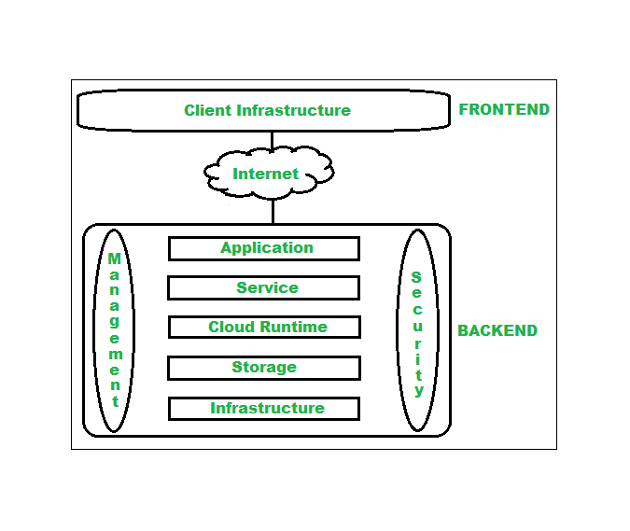

*Architecture of Cloud Computing*

Architecture of cloud computing is the combination of both [SOA (Service Oriented Architecture)](https://www.geeksforgeeks.org/service-oriented-architecture/) and EDA (Event Driven Architecture). Client infrastructure, application, service, runtime, storage, infrastructure, management and security all these are the components of cloud computing architecture.

**1. Frontend :**  
Frontend of the cloud architecture refers to the client side of cloud computing system. Means it contains all the user interfaces and applications which are used by the client to access the cloud computing services/resources. For example use of a web browser to access the cloud plat form.

* **Client Infrastructure –** Client Infrastructure refers to the frontend components. It contains the applications and user interfaces which are required to access the cloud platform.

**2. Backend :**  
Backend refers to the cloud itself which is used by the service provider. It contains the resources as well as manages the resources and provides security mechanisms. Along with this it includes huge storage, virtual applications, virtual machines, traffic control mechanisms, deployment models etc.

1. **Application –**  
   Application in backend refers to a software or platform to which client accesses. Means it provides the service in backend as per the client requirement.
2. **Service –**  
   Service in backend refers to the major three types of cloud based services like [SaaS, PaaS and IaaS](https://www.geeksforgeeks.org/cloud-based-services/). Also manages which type of service the user accesses.
3. **Cloud Runtime –**  
   Runtime cloud in backend refers to provide of execution and runtime platform/environment to the virtual machine.
4. **Storage –**  
   Storage in backend refers to provide flexible and scalable storage service and management of stored data.
5. **Infrastructure –**  
   Cloud Infrastructure in backend refers to hardware and software components of cloud like it includes servers, storage, network devices, virtualization software etc.
6. **Management –**  
   Management in backend refers to management of backend components like application, service, runtime cloud, storage, infrastructure, and other security mechanisms etc.
7. **Security –**  
   Security in backend refers to implementation of different security mechanisms in the backend for secure cloud resources, systems, files, and infrastructure to end-users.
8. **Internet –**  
   Internet connection acts as the medium or a bridge between frontend and backend and establishes the interaction and communication between frontend and backend.

**Benefits of Cloud Computing Architecture :**

* Makes overall cloud computing system simpler.
* Improves data processing requirements.
* Helps in providing high security.
* Makes it more modularized.
* Results better disaster recovery.
* Gives good user accessibility.
* Reduces IT operating costs.

3(a). List out design considerations of Cloud applications?

## Scalability

### Capacity

### Platform / Data

### Load

## Availability

### Uptime Guarantees

### Replication and failover

### Disaster recovery

### Performance

### Security

## Manageability

### Monitoring

### Deployment

## Feasibility

(b). Summarize the benefits of loose coupling in CCM Model?

advantages of making your code loosely coupled include:

* **better testability**  
  because your code isn't dependent on other objects and they are just passed in, this makes your unit tests easier to write.
* **easy-to-understand code**  
  when your code is decoupled from other objects, they are usually passed in or dependency injected into the code. your code provides a self-documenting service to your users.
* **swappable components**  
  while most developers don't think about a plug-in architecture, this is ultimately what developers strive to achieve. if you want to swap out the oracle database component with a sql server component, if developed properly, it can be done easily.
* **scalability**  
  as your system grows, you can provide a diverse number of components to plug into your application, making it more scalable. there is a term i use when a system can't scale properly. it's called "painting yourself into a corner" where you need to re-evaluate your design.
* **isolated code/features**  
  adding new features to a system means that you can write additional code without breaking existing functionality and feel safe writing it.

4. Explain Service Oriented Architecture-SOA for application design?

Service-Oriented Architecture (SOA) is a stage in the evolution of application development and/or integration. It defines a way to make software components reusable using the interfaces.

Formally, SOA is an architectural approach in which applications make use of services available in the network. In this architecture, services are provided to form applications, through a network call over the internet. It uses common communication standards to speed up and streamline the service integrations in applications. Each service in SOA is a complete business function in itself. The services are published in such a way that it makes it easy for the developers to assemble their apps using those services. Note that SOA is different from microservice architecture.

* SOA allows users to combine a large number of facilities from existing services to form applications.
* SOA encompasses a set of design principles that structure system development and provide means for integrating components into a coherent and decentralized system.
* SOA-based computing packages functionalities into a set of interoperable services, which can be integrated into different software systems belonging to separate business domains.

There are two major roles within Service-oriented Architecture:

1. **Service provider:** The service provider is the maintainer of the service and the organization that makes available one or more services for others to use. To advertise services, the provider can publish them in a registry, together with a service contract that specifies the nature of the service, how to use it, the requirements for the service, and the fees charged.
2. **Service consumer:** The service consumer can locate the service metadata in the registry and develop the required client components to bind and use the service.

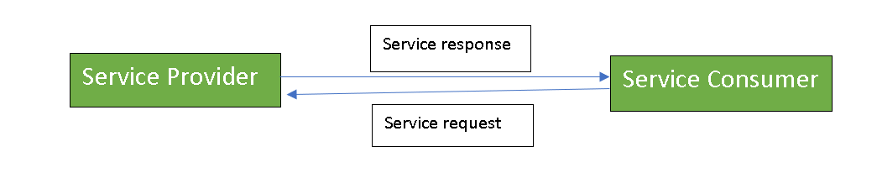

Services might aggregate information and data retrieved from other services or create workflows of services to satisfy the request of a given service consumer. This practice is known as service orchestration Another important interaction pattern is service choreography, which is the coordinated interaction of services without a single point of control.

**Components of SOA:** 

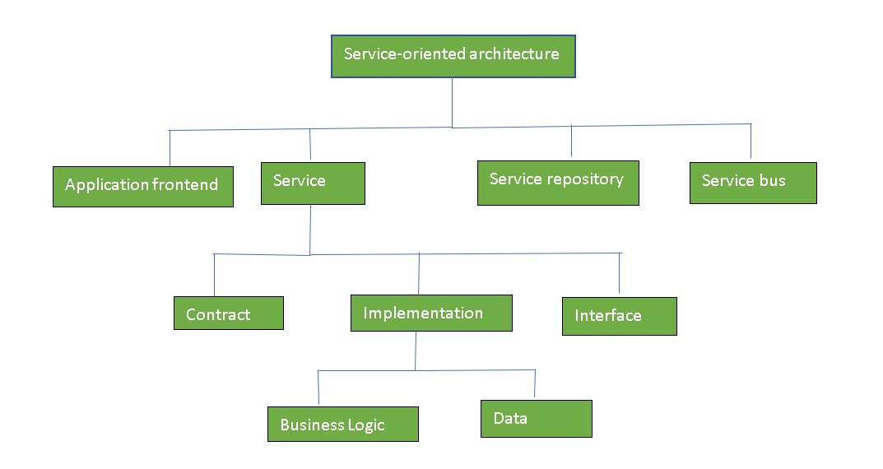

**Guiding Principles of SOA:**

1. **Standardized service contract:**Specified through one or more service description documents.
2. **Loose coupling:** Services are designed as self-contained components, maintain relationships that minimize dependencies on other services.
3. **Abstraction:** A service is completely defined by service contracts and description documents. They hide their logic, which is encapsulated within their implementation.
4. **Reusability:** Designed as components, services can be reused more effectively, thus reducing development time and the associated costs.
5. **Autonomy:** Services have control over the logic they encapsulate and, from a service consumer point of view, there is no need to know about their implementation.
6. **Discoverability:** Services are defined by description documents that constitute supplemental metadata through which they can be effectively discovered. Service discovery provides an effective means for utilizing third-party resources.
7. **Composability:** Using services as building blocks, sophisticated and complex operations can be implemented. Service orchestration and choreography provide a solid support for composing services and achieving business goals.

**Advantages of SOA:**

* **Service reusability:** In SOA, applications are made from existing services. Thus, services can be reused to make many applications.
* **Easy maintenance:** As services are independent of each other they can be updated and modified easily without affecting other services.
* **Platform independent:** SOA allows making a complex application by combining services picked from different sources, independent of the platform.
* **Availability:** SOA facilities are easily available to anyone on request.
* **Reliability:** SOA applications are more reliable because it is easy to debug small services rather than huge codes
* **Scalability:**Services can run on different servers within an environment, this increases scalability

**Disadvantages of SOA:**

* **High overhead:** A validation of input parameters of services is done whenever services interact this decreases performance as it increases load and response time.
* **High investment:** A huge initial investment is required for SOA.
* **Complex service management:** When services interact they exchange messages to tasks. the number of messages may go in millions. It becomes a cumbersome task to handle a large number of messages.

5. Explain steps involved in the Application design of Cloud Components models-CCM

**Cloud computing management** is maintaining and controlling the cloud services and resources be it public, private or hybrid. Some of its aspects include load balancing, performance, storage, backups, capacity, deployment etc. To do so a cloud managing personnel needs full access to all the functionality of resources in the cloud. Different software products and technologies are combined to provide a cohesive cloud management strategy and process.

As we know [Private cloud](https://www.geeksforgeeks.org/features-components-of-private-cloud/)infrastructure is operated only for a single organization, so that can be managed by the organization or by a third party. Public cloud services are delivered over a network that is open and available for public use. In this model, the IT infrastructure is owned by a private company and members of the public can purchase or lease data storage or computing capacity as needed. Hybrid cloud environments are a combination of public and private cloud services from different providers. Most organizations store data on private cloud servers for privacy concerns, while leveraging public cloud applications at a lower price point for less sensitive information. The combination of both the public and private cloud are known as Hybrid cloud servers.

**Need of Cloud Management :**  
Cloud is nowadays preferred by huge organizations as their primary data storage. A small downtime or an error can cause a great deal of loss and inconvenience for the organizations. So as to design, handle and maintain a cloud computing service specific members are responsible who make sure things work out as supposed and all arising issues are addressed.

**Cloud Management Platform :**  
A cloud management platform is a software solution that has a robust and extensive set of APIs that allow it to pull data from every corner of the IT infrastructure. A CMP allows an IT organization to establish a structured approach to security and IT governance that can be implemented across the organization’s entire cloud environment.

**Cloud Management Tasks :**  
The below figure represents different cloud management tasks :

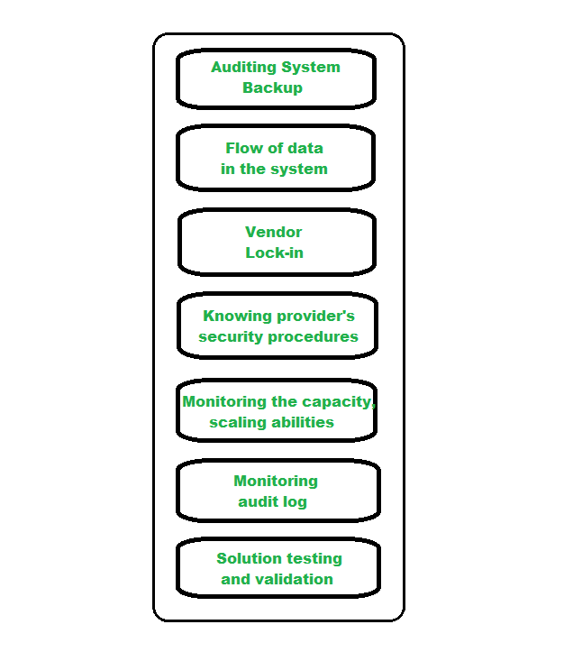

*Cloud Management Tasks*

* **Auditing System Backups –**  
  It is required to audit the backups from time to time to ensure restoration of randomly selected files of different users. This might be done by the organization or by the cloud provider.
* **Flow of data in the system –**  
  The managers are responsible for designing a data flow diagram that shows how the data is supposed to flow throughout the organization.
* **Vendor Lock-In –**  
  The managers should know how to move their data from a server to another in case the organization decides to switch providers.
* **Knowing provider’s security procedures –**  
  The managers should know the security plans of the provider, especially Multitenant use, E-commerce processing, Employee screening and Encryption policy.
* **Monitoring the Capacity, Planning and Scaling abilities –**  
  The manager should know if their current cloud provider is going to meet their organization’s demand in the future and also their scaling capabilities.
* **Monitoring audit log –**  
  In order to identify errors in the system, logs are audited by the managers on a regular basis.
* **Solution Testing and Validation –**  
  It is necessary to test the cloud services and verify the results and for error-free solutions.